# Common Cents Party Web Project



The band, Common Cents Party, has asked you to work on two webpages for their website. Now that you have been introduced to some fundamental HTML elements, you are ready to help the band. Let’s get started.

* **In your Computing folder create a new folder called Common Cents Party.**
* **Save the 3 files index.html, shows.html and style.css into this folder.**
* **Open index.html in Notepad++ and work through the tasks on the next page**
* **You can test and see how the html will be displayed in your browser by right clicking on the file and choosing Open with Internet Explorer (or any of the other browsers)**

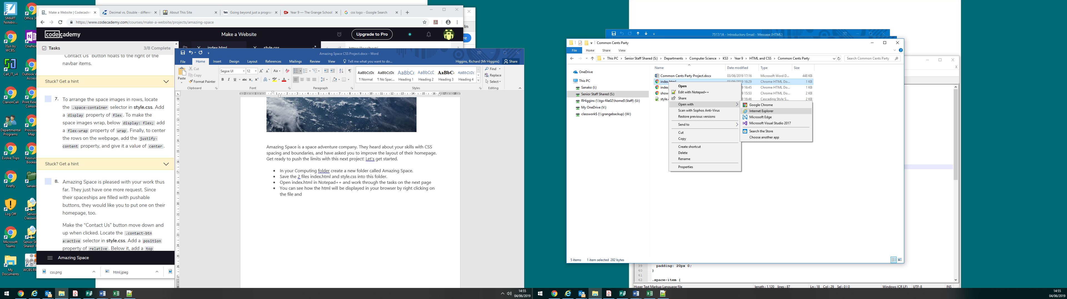

**1.**

Start by creating the page structure.

In **index.html**, there are currently three divs on the page. The div with class container has two children. Set the class of the first child div to nav. Set the class of the second child div to main.

**2.**

Inside the div with class nav, create an h4 element which displays “Common Cents Party” to serve as the navbar heading.

**3.**

Below the h4, create a ul element with li items for different pages the site offers:

* Home
* Shows
* Albums
* Gallery
* Bio
* Blog

**4.**

Next, inside the div with class main, create an h1 heading element that displays “Common Cents Party”.

**5.**

Below the h1 heading, create an image element that has the following image URL as its src attribute:

https://s3.amazonaws.com/codecademy-content/projects/make-a-website/lesson-1/band.jpg

**6.**

Below the image of the band, create a paragraph element to include a recent review:

“Common Cents Party, a hard-hitting acoustic punk/electronic four-piece from Atlanta, Georgia, combines an unleashed live performance with edgy lyrics, unforgettable hooks and well-studied synth-rock sounds. A must-see, must-hear new band.” -Screech Magazine

**7.**

Next, create an anchor element that links users to a list of the band’s upcoming shows.

The href attribute for the anchor element should be set to shows.html. The text for the anchor could say “Here’s a list of upcoming shows”.

Test out your anchor element in the web browser.

**8.**

The band has asked you to include video from a recent live performance.

In the file **shows.html**, below the h1 heading that displays “Upcoming Shows”, create a video element.

Play with the height and width attributes until the video’s size looks right to you. Then, set the video source to:

https://s3.amazonaws.com/codecademy-content/projects/make-a-website/lesson-1/liveshow.mp4

Play the video in the web browser to make sure it works.

**9.**

Click [here](https://www.youtube.com/watch?v=SfHnXCqSi9g) for a video walkthrough from our experts to help you check your work!

**Extension activity:**

**Create your own web page for your favourite band by hacking your Common Cents Party website with content from your bands website.**

Tips:

* Create a new folder and copy all your Common Cents files into it before you start to hack them
* Copy text from the website of your chosen band and paste it into your html files using notepad++. Remember to set the language to html
* Remember to modify the style sheet to suit the style of your bands website
* Save images as files in your new folder that you want to use in your hacked website. In your html just use the image name like the example below:

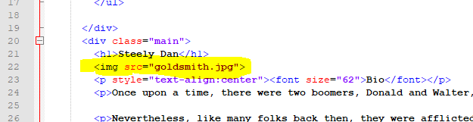

* You can test and see how the html will be displayed in your browser by right clicking on the file and choosing Open with Internet Explorer (or any of the other browsers)

